Gary Heberling

IST 210 Getting Started with VLabs

Taylan Unal

**Step 6:  “SELECT * FROM MSC_JOB”**

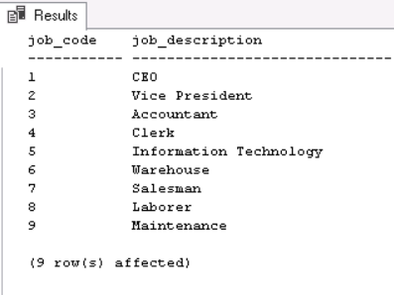job_code job_description

----------- ------------------------------

1 CEO

2 Vice President

3 Accountant

4 Clerk

5 Information Technology

6 Warehouse

7 Salesman

8 Laborer

9 Maintenance

(9 row(s) affected)

**Step 10: “SELECT * FROM MSC_ORDER_DETAIL WHERE ord_quantity = 297” (!)**

ord_number line_number prod_number ord_quantity ship_quantity ship_date

----------- ----------- ----------- --------------------------------------- --------------------------------------- ----------

81012 10 4014 297 297 2016-11-08

(1 row(s) affected)

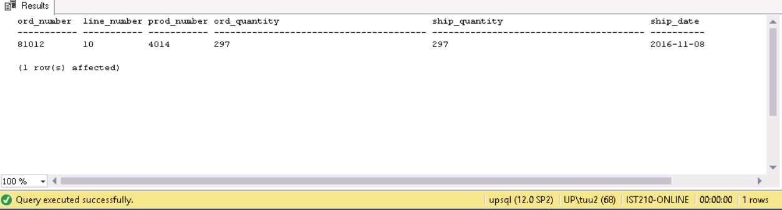

**Step 11: “SELECT empl_first_name, empl_last_name FROM MSC_EMPLOYEE”**

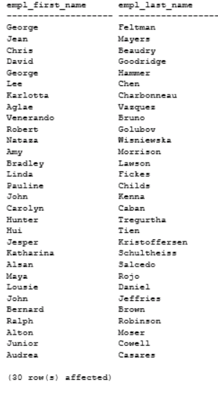empl_first_name empl_last_name

-------------------- --------------------

George Feltman

Jean Mayers

Chris Beaudry

David Goodridge

George Hammer

Lee Chen

Karlotta Charbonneau

Aglae Vazquez

Venerando Bruno

Robert Golubov

Nataza Wisniewska

Amy Morrison

Bradley Lawson

Linda Fickes

Pauline Childs

John Kenna

Carolyn Caban

Hunter Tregurtha

Hui Tien

Jesper Kristoffersen

Katharina Schultheiss

Alsan Salcedo

Maya Rojo

Lousie Daniel

John Jeffries

Bernard Brown

Ralph Robinson

Alton Moser

Junior Cowell

Audrea Casares

(30 row(s) affected)